**Prevention of Cancellations**

- Shithi Maitra, Jr. Data Scientist

**ML-based Cancel Predictor: Technicalities, Insights and APs**

* Mined prospective cancels using ML and mapped them on Metabase: <http://mb.sheba.xyz/question/16708>
* Made the cancel-prediction model more efficient: trained on a set of 39k examples, handled NULLs more effectively.
* Designed a tracker for tracking efficiency of the ML-based cancel predictor: <http://mb.sheba.xyz/question/16744>
* Delivered the first round of prospective cancels.
* Did more hyperparameter tuning to the ML model to predict cancels.
* Operationalized the usage of the cancel predictor.
* Got CX started into running the procedure of cancel-reduction.
* Updated, monitored ML-based prediction of cancellations time-to-time.

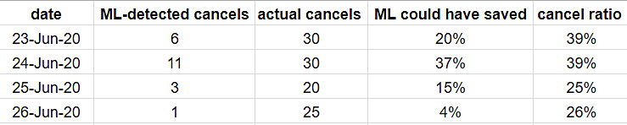

**Profiling of Customers for MKT: Technicalities, Insights and APs**

* Customer Profiling: GMV-wise: <http://mb.sheba.xyz/question/16793?seg_num=9>
* Customer Profiling: Order-wise: <http://mb.sheba.xyz/question/16794?mcat=Appliance%20Repair&cdate=2019-09-01~2020-02-29&seg_num=3>

**Telesales, FB Lookalikes, Gender-based SMS Campaigns: Technicalities, Insights and APs**

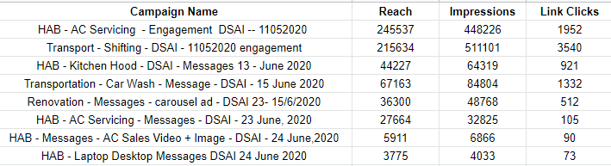

* Reused gender-data for MX campaign (my laptop): F:\Sheba\knowing the data\Revamp Telesales Post COVID
* Segmented out male customers using ML and sent their numbers for FB lookalike campaigns for Men's Care.
* Provided MKT lookalike customers' data separately for: car care, rent a car, shifting.
* 25,278 male customers were detected almost perfectly and have been sent to for lookalike generation for Men's Care
* Began the MX Lookalike campaigns on FB.
* Got telesales started and aligned what and how to pitch.